A

VIJAYAKUMARAN M

vijayakumaran2004@gmail.com

Architecture Document

Thyroid Disease Detection

**1 Introduction**

**1.1 Purpose**

This architecture document provides an architectural overview of the solution, depicting its different aspects using different views. It is intended to capture and convey the significant architectural decisions made.

**1.2 Scope**

This architecture document provides an architectural overview of the Thyroid Disease Detection solution. This solution is developed by Kumar Trinayan Bharadwaj under an internship in iNeuron.

**2 Architecture Representation**

This document presents the architecture as a series of views; use case view, logical view, process view and deployment view. There is no separate implementation view described in this document.

**3 Use Case View**

A description of the use-case view of the software architecture. The Use Case View is important input to the selection of the set of scenarios and/or use cases that are the focus of an iteration. It describes the set of scenarios and/or use cases that represent some significant, central functionality.

The thyroid disease detection use cases are:

* Click the link and enter the homepage
* Enter the patient details (TSH, T4U, FTI and TT4)
* Hit the predict button
* Get the result

**5 Process View**

A description of the process view of the architecture. Describes the tasks (processes and threads) involved in the system's execution, their interactions and configurations.

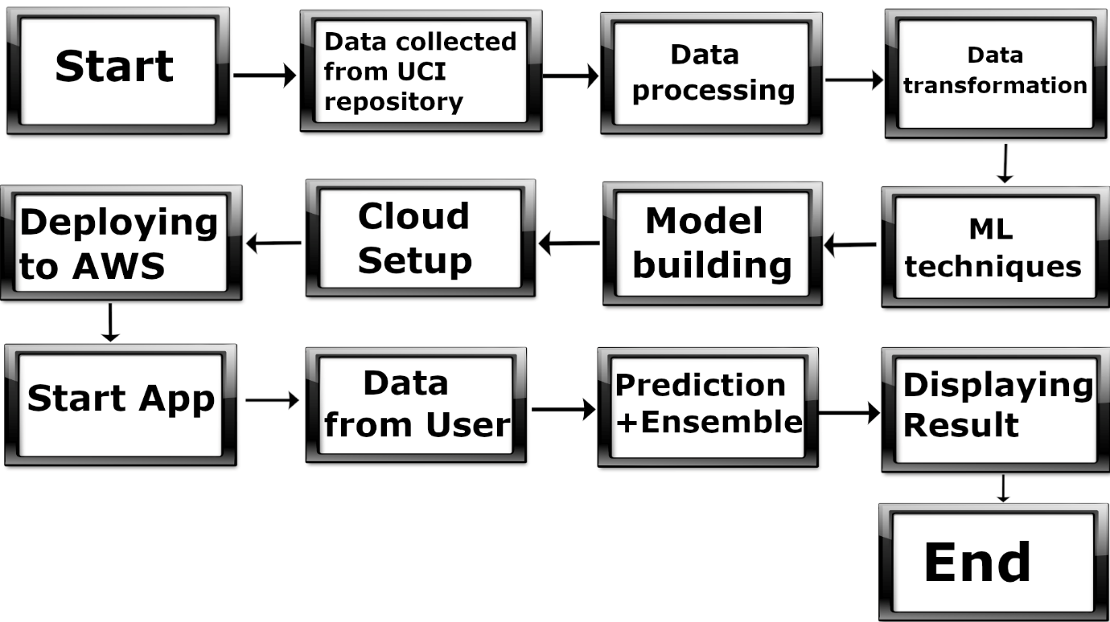

**6 Deployment view**

A description of the deployment view of the architecture Describes the various physical nodes for the most typical platform configurations. Also describes the allocation of tasks (from the Process View) to the physical nodes.

